Practices for Lesson 6: Object and Data Modelling

Practices for Lesson 6

Overview

In these practices, we will learn to navigate to several screens and views, the relationships between the objects using About View. Further, you will verify if the webtools are installed in your instance for using object explorer.

Practice 6-1: Understanding Object Explorer and Tools and Create and manage records

**Overview**

In this practice, you will navigate to several screens and views and examine the relationships between the objects using About View.

Assumptions

You should have completed the Practices of Lesson 5.

**Tasks**

1. Open Browser and Start the WebApp URL, Login as SADMIN.

**Explore contact views**.

1. Navigate to **Contacts > Contacts List.**
2. In the application-level menu, select **Help** and click **About View** as shown below.  
   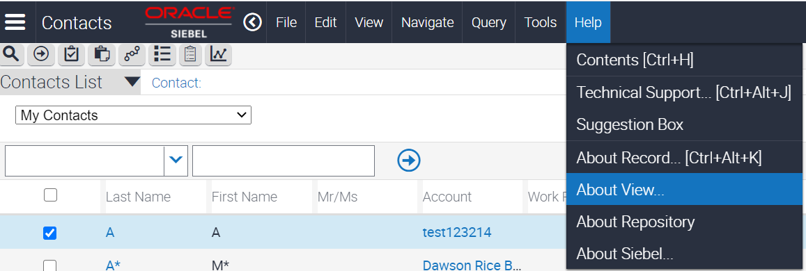
3. Details of the view are displayed as shown below.

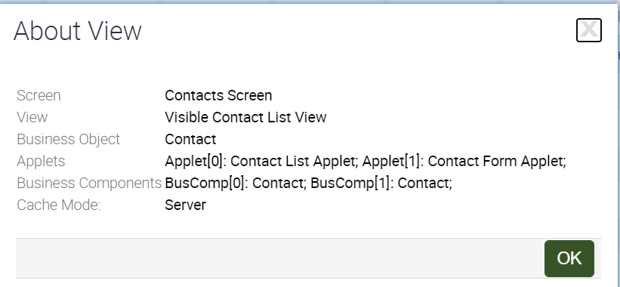

1. You will see that the "parent" business component (BC) identified by the 0 and the "child" BC identified by the 1 are the same. This is often the case in a list view, since you are seeing the same data in the list and form applets.
2. You will also notice the naming convention. List applets often have "List Applet" in their names while form applets often have "Form Applet" in their name.
3. Click **OK**
4. Drill down on Last Name (**Click on Last Name Link** – Any of the record). You will be navigated to a detail view.
5. In the drop-down menu (2nd Level menu), click **Accounts**. You need to use the drop-down arrow.
6. In the application-level menu**,** select **Help** and click **About View.**  
   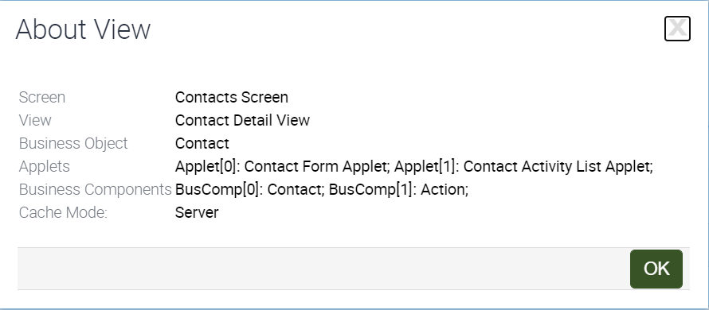
7. You will see the screen and business object are the same as the former list view. This means that the "context" for the data has not changed.
8. Notice that the "parent" BC is still Contact. That means that contact data is driving the rest of the data in the view (other data is related to or in the context of the contact).
9. The "parent" applet is based on the same BC (Contact), and the "child" applet is based on a different business component (Account). You are seeing account data that is related to the contact.
10. Click **OK**
11. In the form applet, move to the next contact record.
12. In the bottom list applet, notice that you are seeing a different set of accounts. This is because the link is being used to properly relate business components. The link uses primary and foreign keys to relate the data so that you are seeing the child records that are associated with this particular parent record
13. Exploring account views
14. First, navigate to **Menu,** then navigate to **Accounts** and then to **Accounts List.**
15. In the application-level menu, select **Help** and click **About View**.

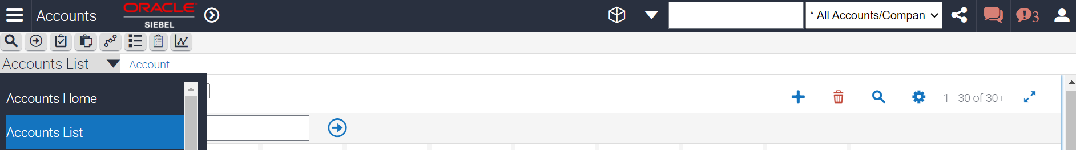

1. You will see that this is the same Account BC that you saw in the contacts view.   
   However, in this case it is the parent or primary BC in the Business Object (BO). The BC exposes the same data, just in a different BO context. Here, account data is driving the other data in the view.
2. Click **OK**.
3. Drill-down to the Name**. (Click on Name – Any of the record).** You will be navigated to a detail view.

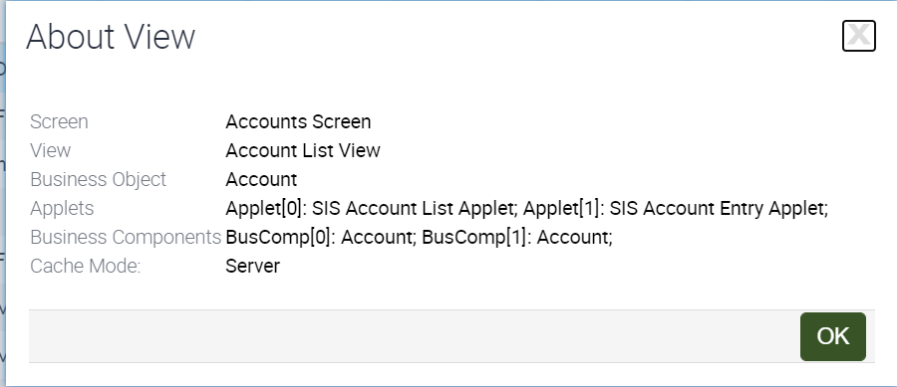

1. You will see that this is the same Contact BC that you saw in the contacts view. However, in this case it is the child BC. It exposes the same data, but it is now in the context of the account.
2. In the contacts list applet, notice that you are not seeing all the contacts, you are only seeing the contacts that are associated with the account in the top applet.
3. Click **OK.**
4. In the form applet, navigate to the next account record.
5. In the list applet, notice that you are seeing a different set of contacts that are associated with this account. Again, the link controls the data that is displayed in the child applet.
6. Explore administration views.
   1. Navigate to **Administration**, then to **Application** and click **System Preferences**.
   2. In the application-level menu, select **Help** and click **About View**.

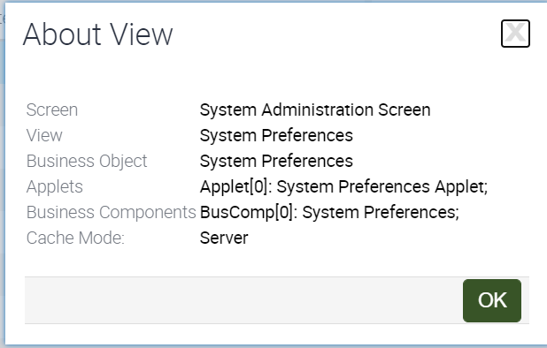

* 1. Notice that there is only one applet in this view. A view can have one or many applets.
  2. Click **OK.**
  3. Navigate to **Administration - Application > Responsibilities.**

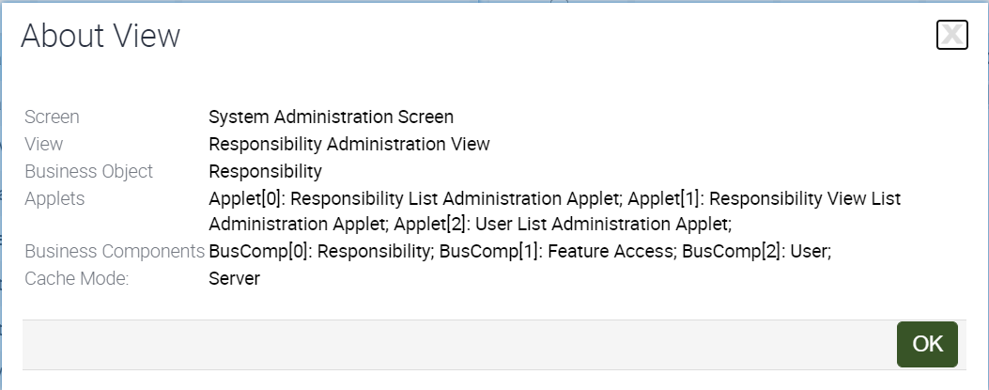

* 1. In the application-level menu, select **Help > About View**.
  2. Notice that the screen is the same, but the BO is different. This is common in administration screens. Each view may have its own context.
  3. Notice also that this view has three business components. The two child applets are shown side by side.
  4. Click **OK**

Practice 6-2: Web Tools Verification

**Overview**In this practice, you will verify if the webtools are installed in your instance for using object explorer.

Assumptions

You should have completed the Practices of Lesson 6-1.

**Tasks**

1. Access the SMC Console URL. The URL is provided by the Instructor (4430:/siebel/smc)
2. Enter: User ID SADMIN   
   Enter Password : (for SADMIN)  
   Click **Login**

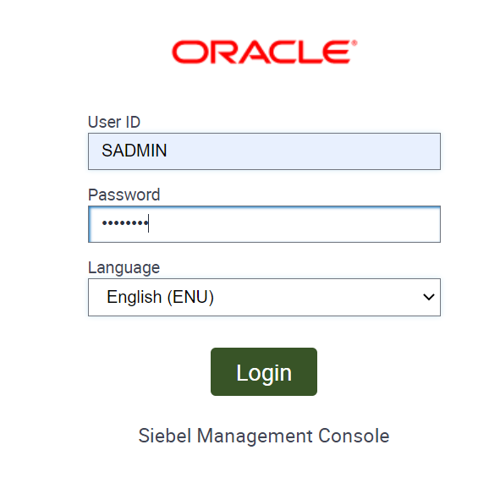

1. Click on **Profiles** and click **Siebel Server**.

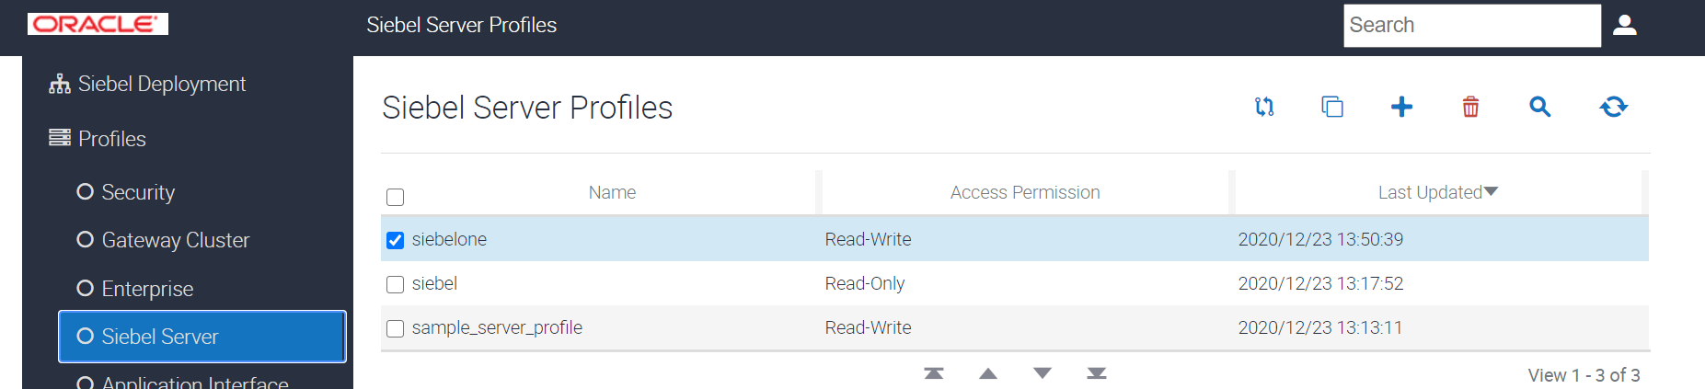

1. In the right side of the pane, you will see Server profiles. Down the screen in the same pane (frame), you will see component groups.
2. Enable Siebel Web Tools as shown below. This confirms Siebel Web Tools is Installed in the instance.

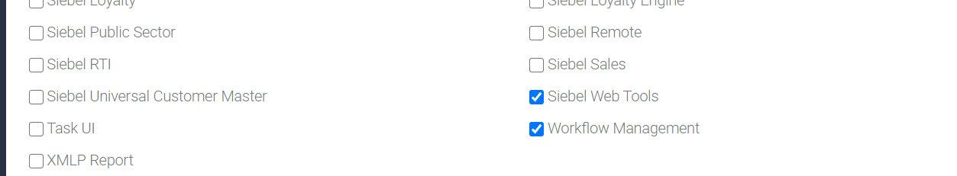

1. Verify that the Webtool is accessible through the below url. This verifies if Siebel Web Tools is installed in the instance.

https://<<instance-ip>>:4430/siebel/app/webtools/enu?SWECmd=Start

Username - **sadmin**

Password - <<same password of sadmin>>

This opens the webtools console of the application